ASSIGNMENT 2

NAME : PANDIDURAI M

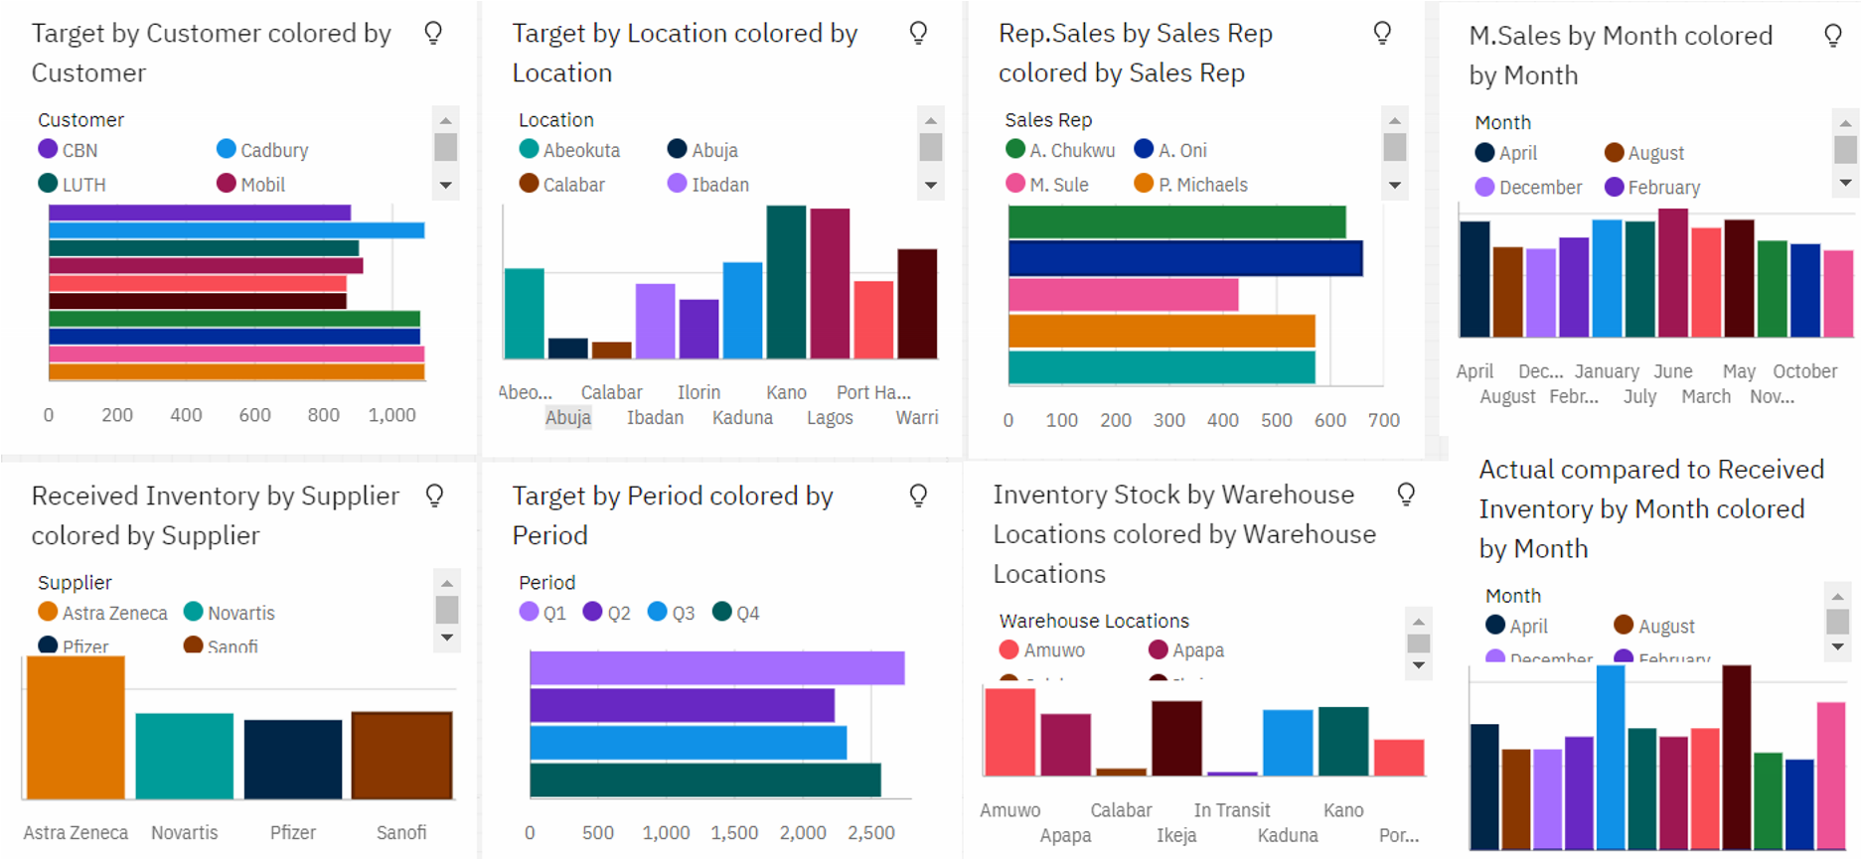 https://us1.ca.analytics.ibm.com/bi/?perspective=dashboard&pathRef=.my_folders%2FASSIG

NMENT%2FAssignment%2B2&action=view&mode=dashboard&subView=model000001836a68 5ba6_00000000